Slim CD Shopping Cart Plugins

API Access Credential Setup 2
Hosted Page Setup 4
WooCommerce Setup 6
Magento Setup 9
Results 11

API Access Credential Setup

An API Access Credential gives your shopping cart access to your Slim CD account. To set up a credential, log into your Slim CD account and navigate to config -> API Access Credentials. Then, click “Create New Access Credential”
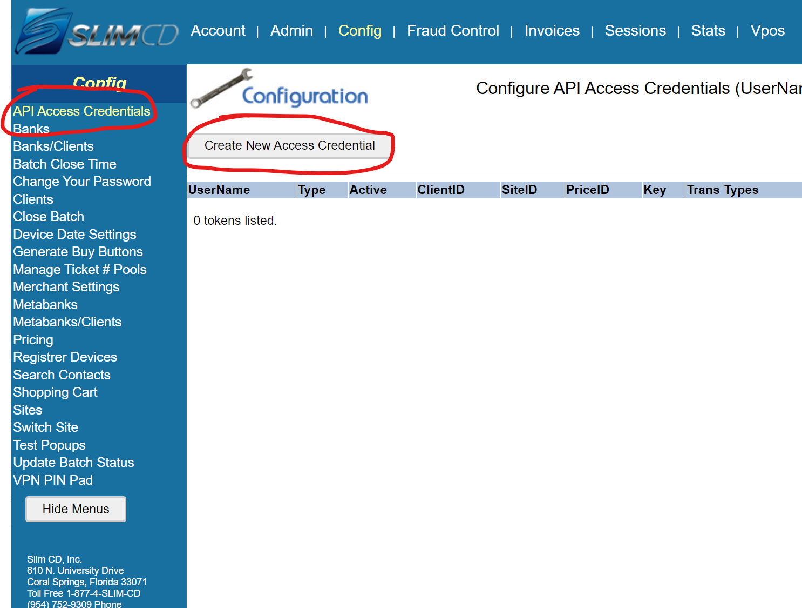
Choose your Site ID from the drop-down, and Choose Private API UserName. Check the boxes for permission to access Login.ASMX as well as either AUTH, SALE, or both (depeding on what your cart will be doing, SALE is the default) and Check Session.
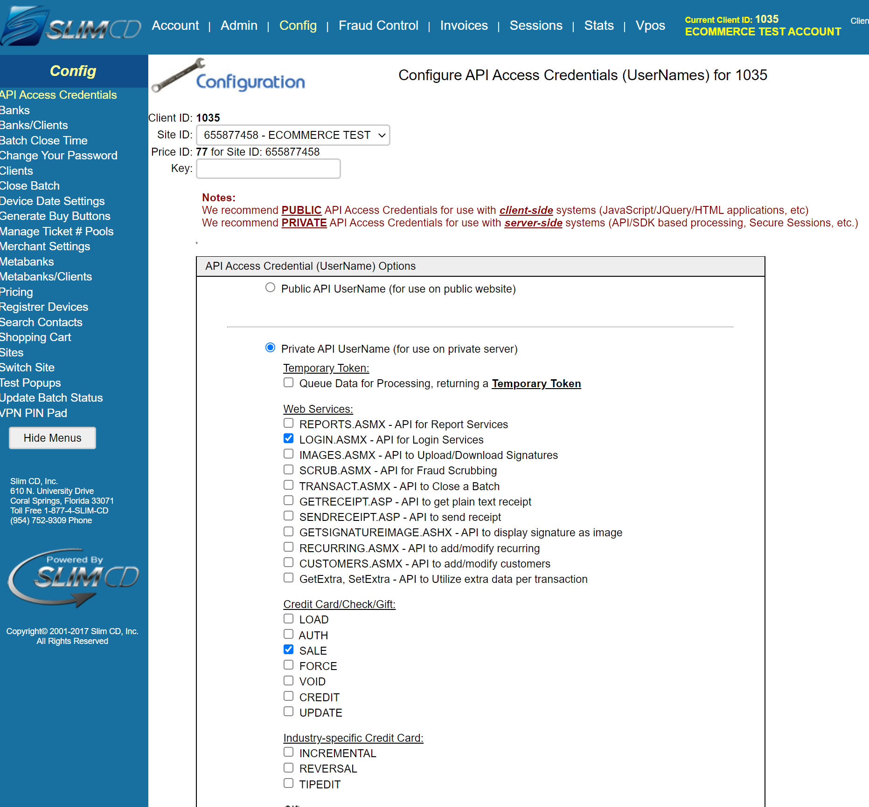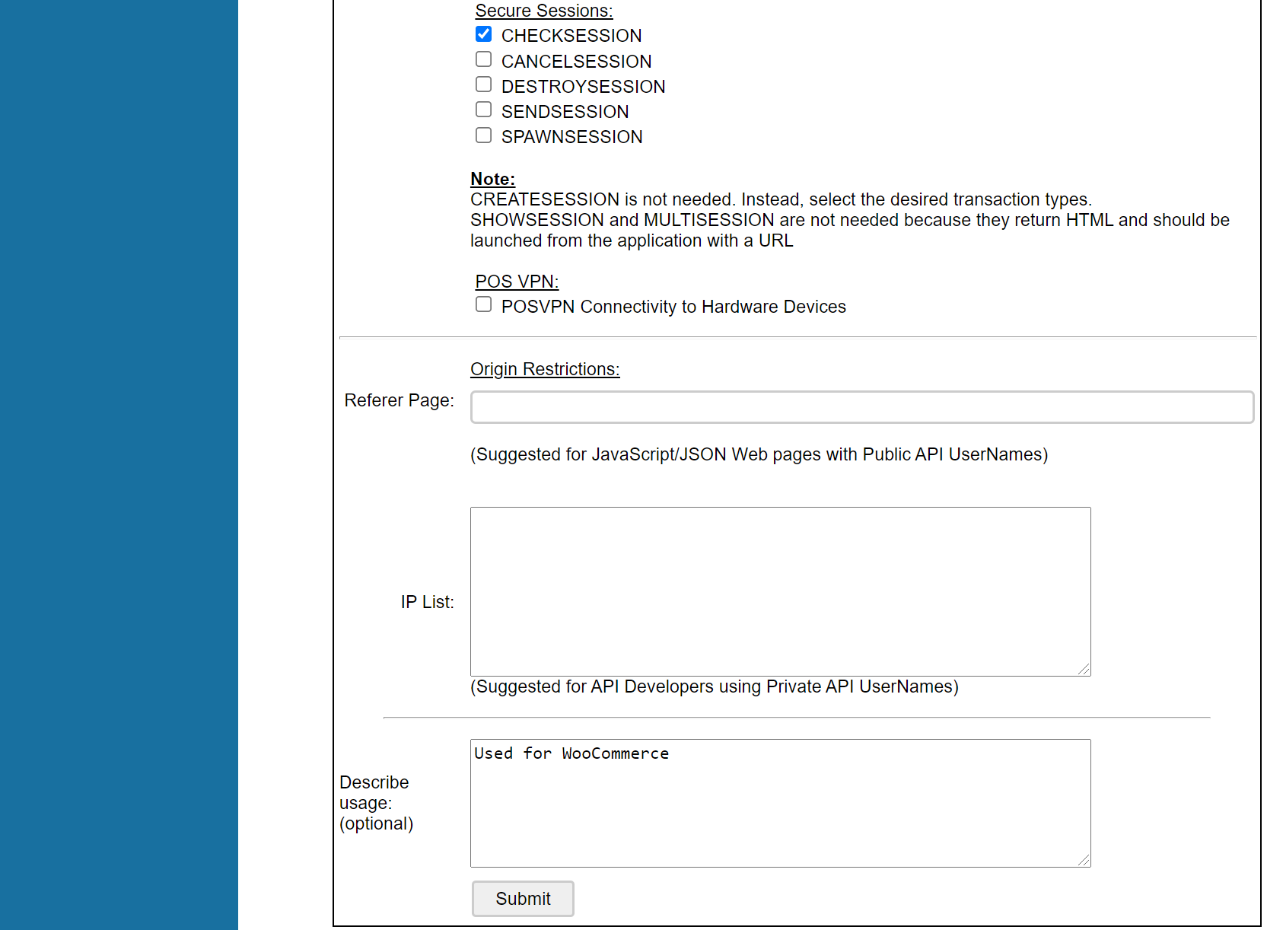
Add a note to describe the usage if you wish, then Submit to create the credential. You can then copy the UserName code to your cart’s configuration (see section on configuration for your cart).

Hosted Page Setup

A hosted payment page is required on your Slim CD account for use of our shopping cart plugins. There is a basic template you can use, and also adjust in a number of ways. Slim CD support must enable hosted payment pages on your account, and will copy in the proper page template for your shopping cart. You can click the Edit Form button to add your own logo or adjust colors of the page:
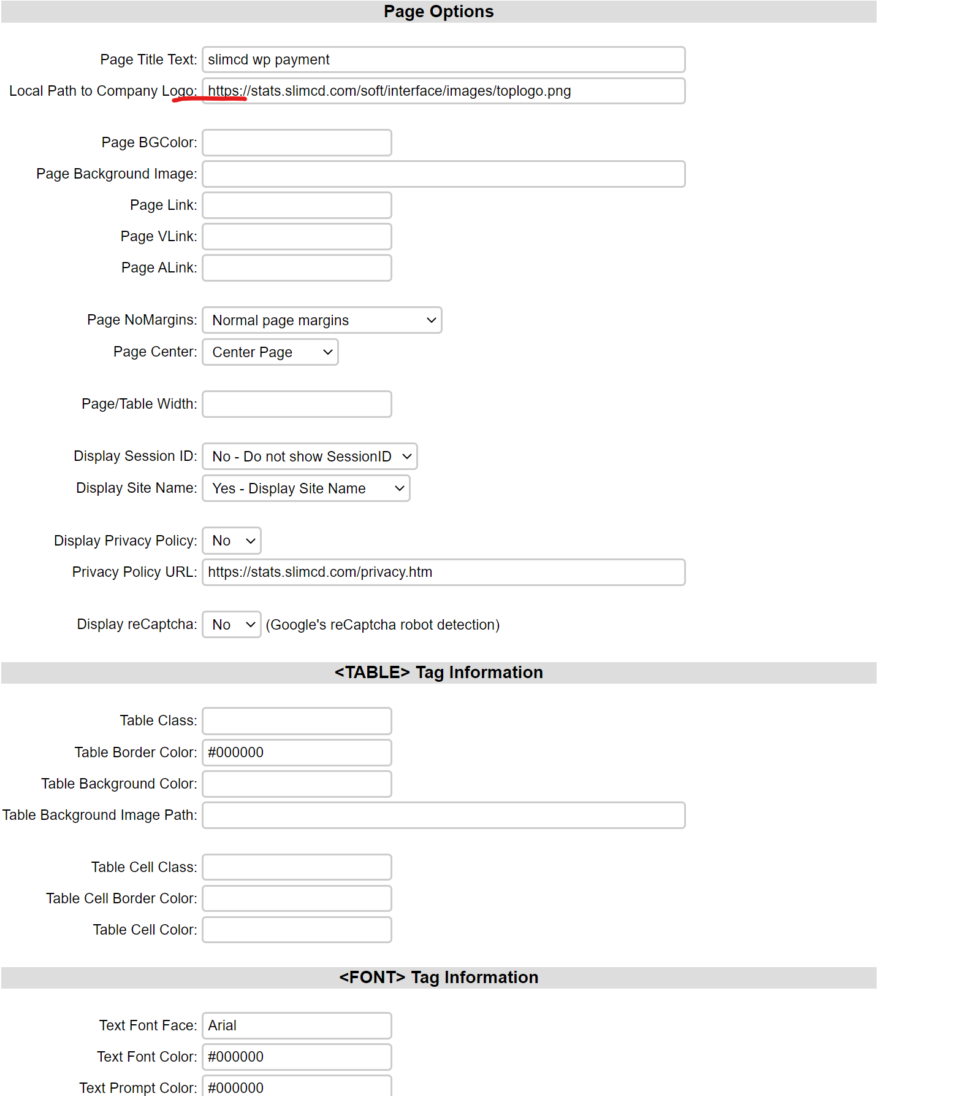
Click the “Go to Advanced Settings Page” button at the top to see more controls of the page including what to do with duplicates, how many declines to allow, and a few options for what types of card to accept. You can also set dollar amount limits and security requirements.
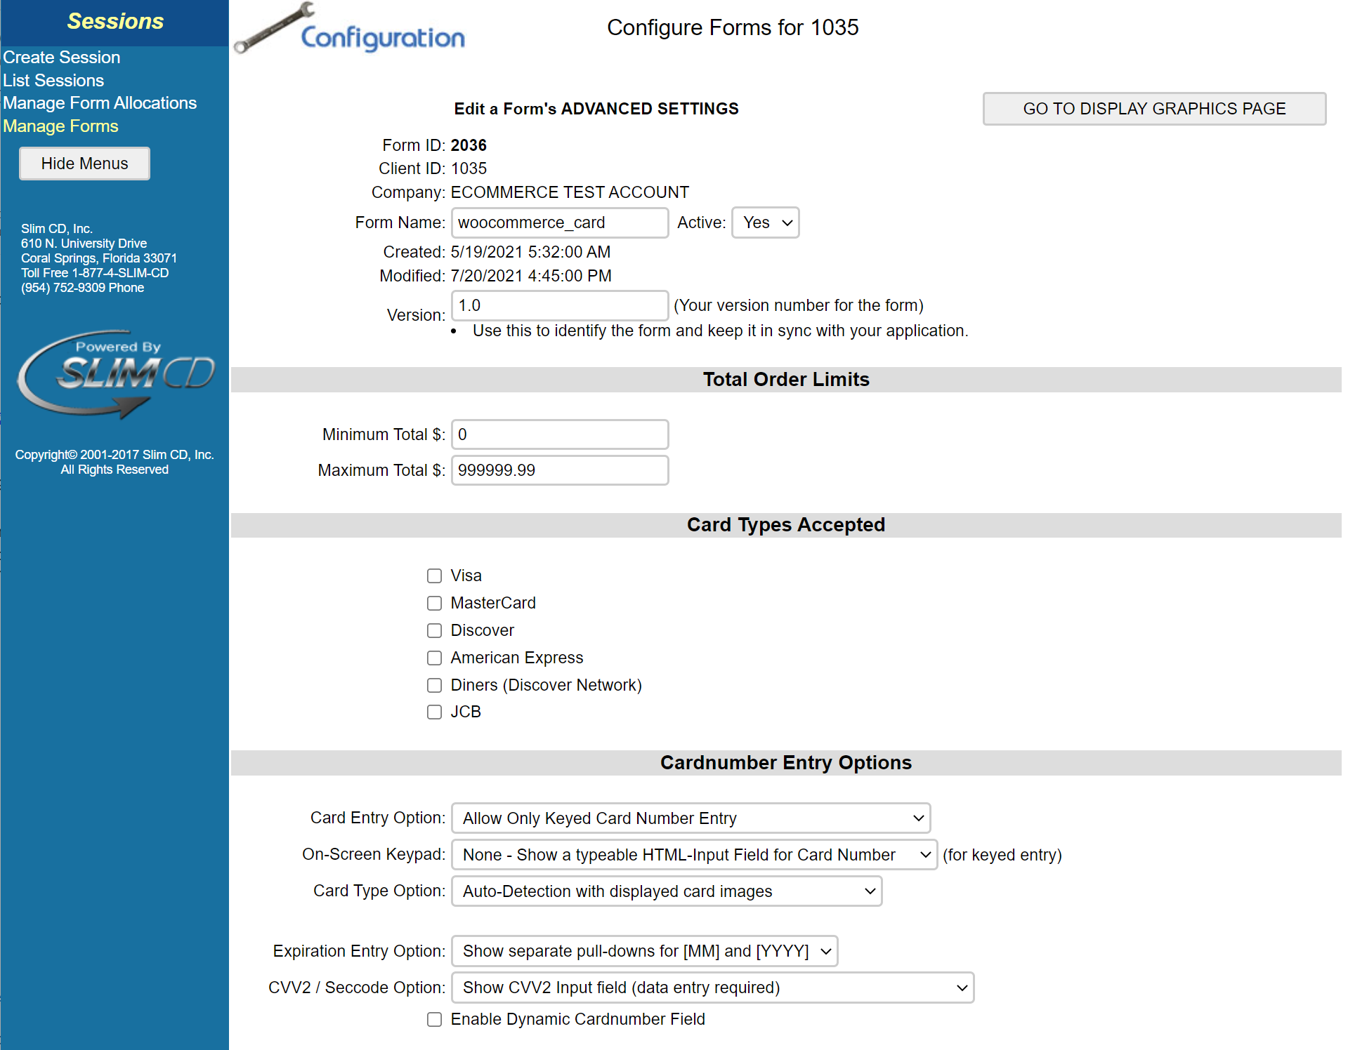
Further down you will find the post back and redirect URL fields. This is where you will insert the post back and redirect URLs that the shopping cart plugin will show you (see appropriate section below). These URLs are necessary to allow the payment page to direct back to the cart after payment is complete, and to notify the shopping cart of the payment result.
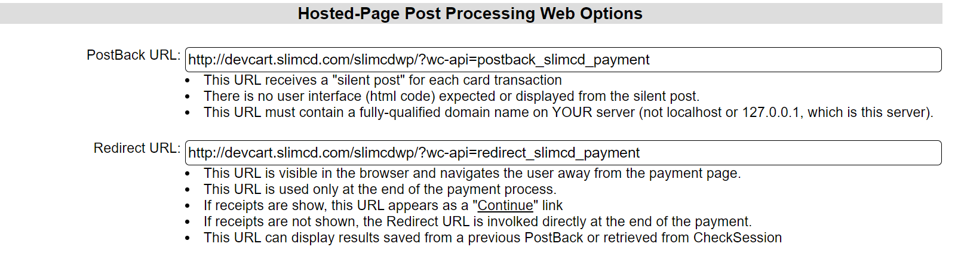
Note: these are examples from the Slim CD test cart. You must enter your own local URLs for proper operation.

WooCommerce Setup

Once you install the Slim CD WooCommerce Plugin, from WordPress you can find the setup options from WooCommerce -> Settings -> Payments tab -> click the Manage button on the Slim CD Payment Gateway menu
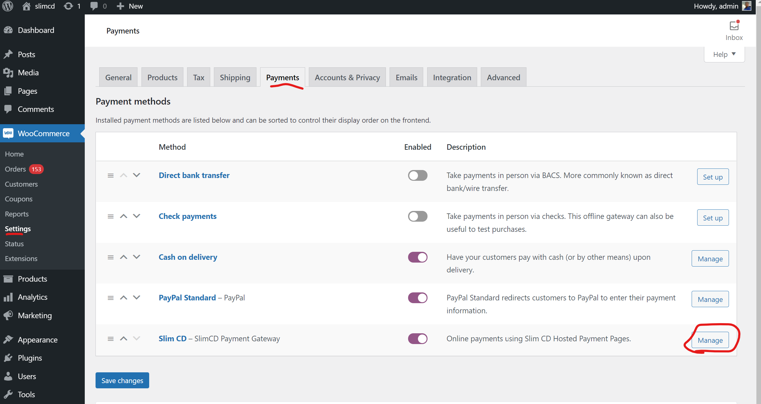
Here you will see the configuration settings for the Slim CD WooCommerce plugin.
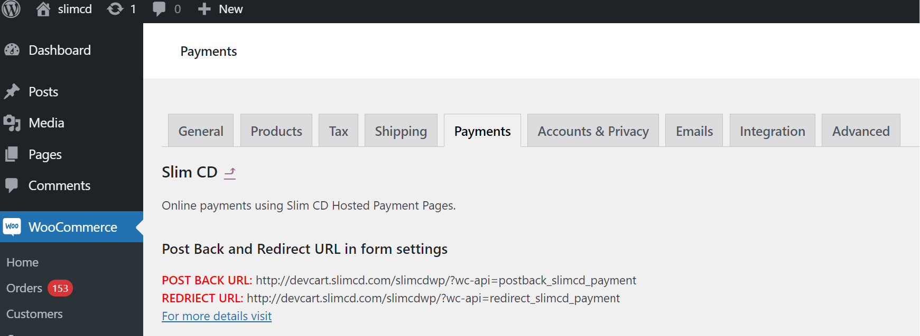
Post Back URL: this is the URL you should use on the hosted payment page so that it can inform the cart that a payment is complete.
Redirect URL: this is the URL you should use on your hosted payment page so that it can direct the customer back to the cart after a payment is complete.

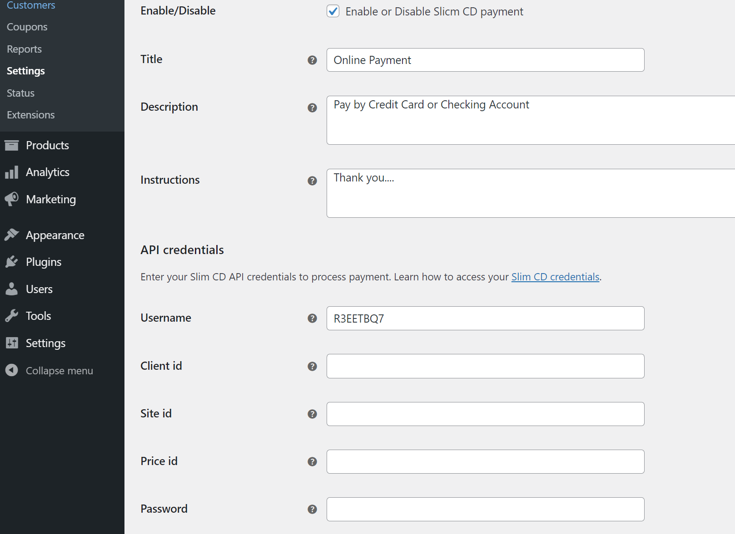
Enable/Disable: toggle whether Slim CD payments are an option in your cart.
Title: The title for the Slim CD payment option.
Description: More information on this option.
Instructions: any additional instructions you would like to add to the checkout page
API Credentials: The username you generate (or have Slim CD support generate) should be pasted here. This is how the cart identifies itself and ties itself to your Slim CD account. The other fields are an alternative method and not recommended, leave them blank.

Credit Card Options
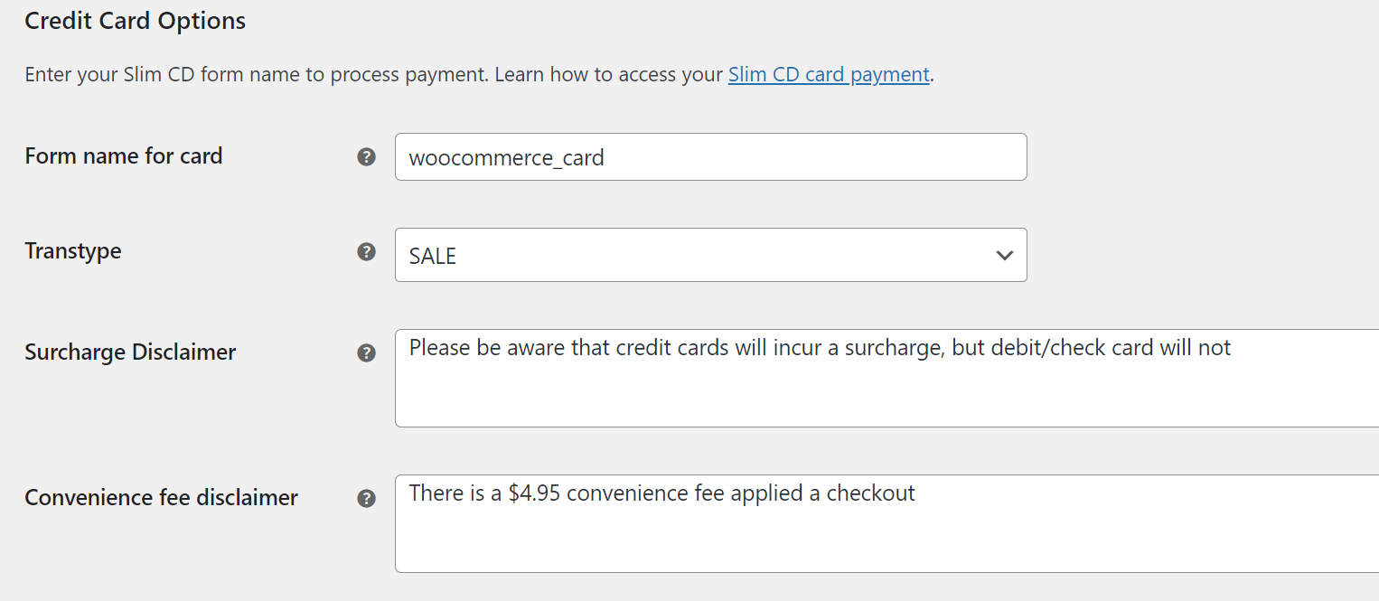
Form name: the name of the hosted payment page on your account that is used for credit card payment.
Transtype: choose which transaction type the cart should perform.
- Choose sale to have the page immediately charge the customer’s card.
- Choose AUTH if you wish the transaction to only be authorized (you will have to complete it with a FORCE within Slim CD to receive the funds).
Surcharge Disclaimer: if you have surcharge enabled on your account, enter the text you wish your customers to see regarding surcharge (will only appear if surcharge is enabled).
Convenience fee Disclaimer: if you have convenience fee enabled on your account, enter the text you wish your customers to see regarding convenience fee for cards (will only appear if convenience fee is enabled).
Check Payment Details
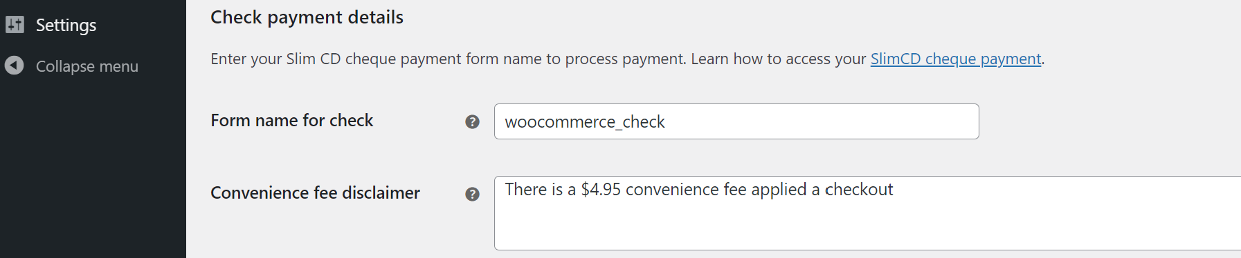
Form Name: the name of the hosted payment page on your account that is used for check payment
Convenience fee Disclaimer: if you have convenience fee enabled on your account, enter the text you wish your customers to see regarding convenience fee for checks (will only appear if convenience fee is enabled).

Magento Setup

Once you install the Slim CD for Megento plugin, you can access its configuration from Stores -> Configuration -> Sales -> Payment Methods. Find the Slim CD section to see the options.
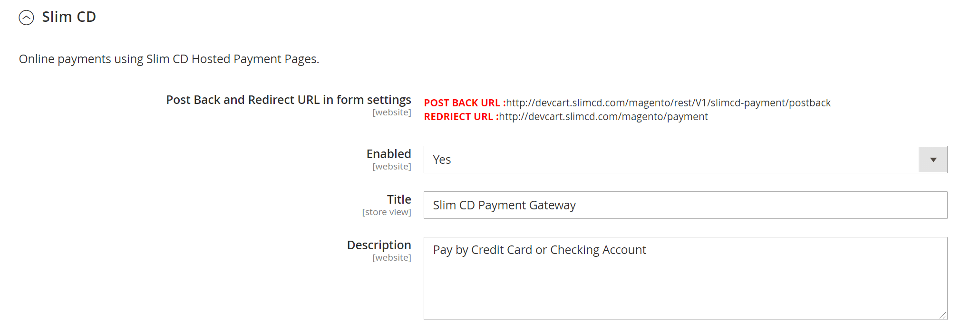
Post Back URL: this is the URL you should use on the hosted payment page so that it can inform the cart that a payment is complete.
Redirect URL: this is the URL you should use on your hosted payment page so that it can direct the customer back to the cart after a payment is complete.
Enabled: whether the Slim CD plugin is enabled as a payment option or not.
Title: The title for the Slim CD payment option.
Description: More information on this option.
API Credentials
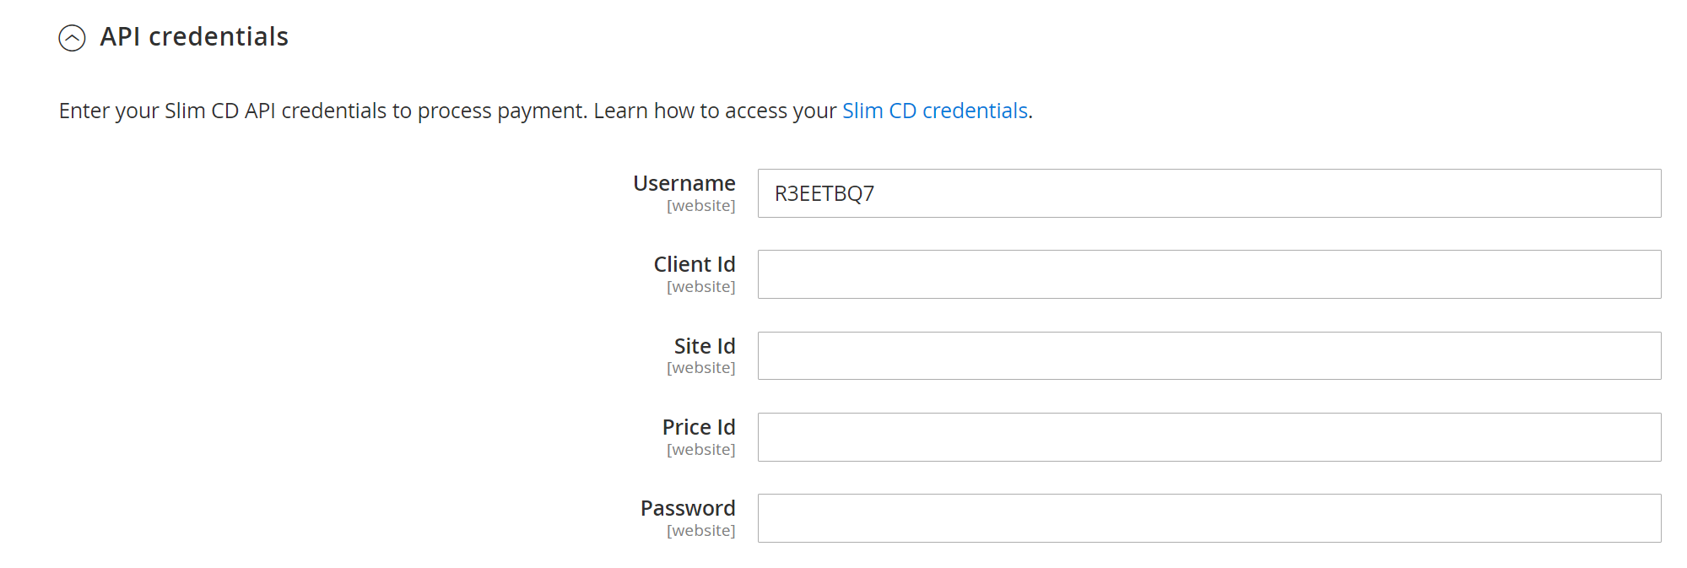
Username: enter your API Access Credential generated on slimcd.com. Alternatively you can enter the other fields, but Username by itself is recommended.

Card Payment Details
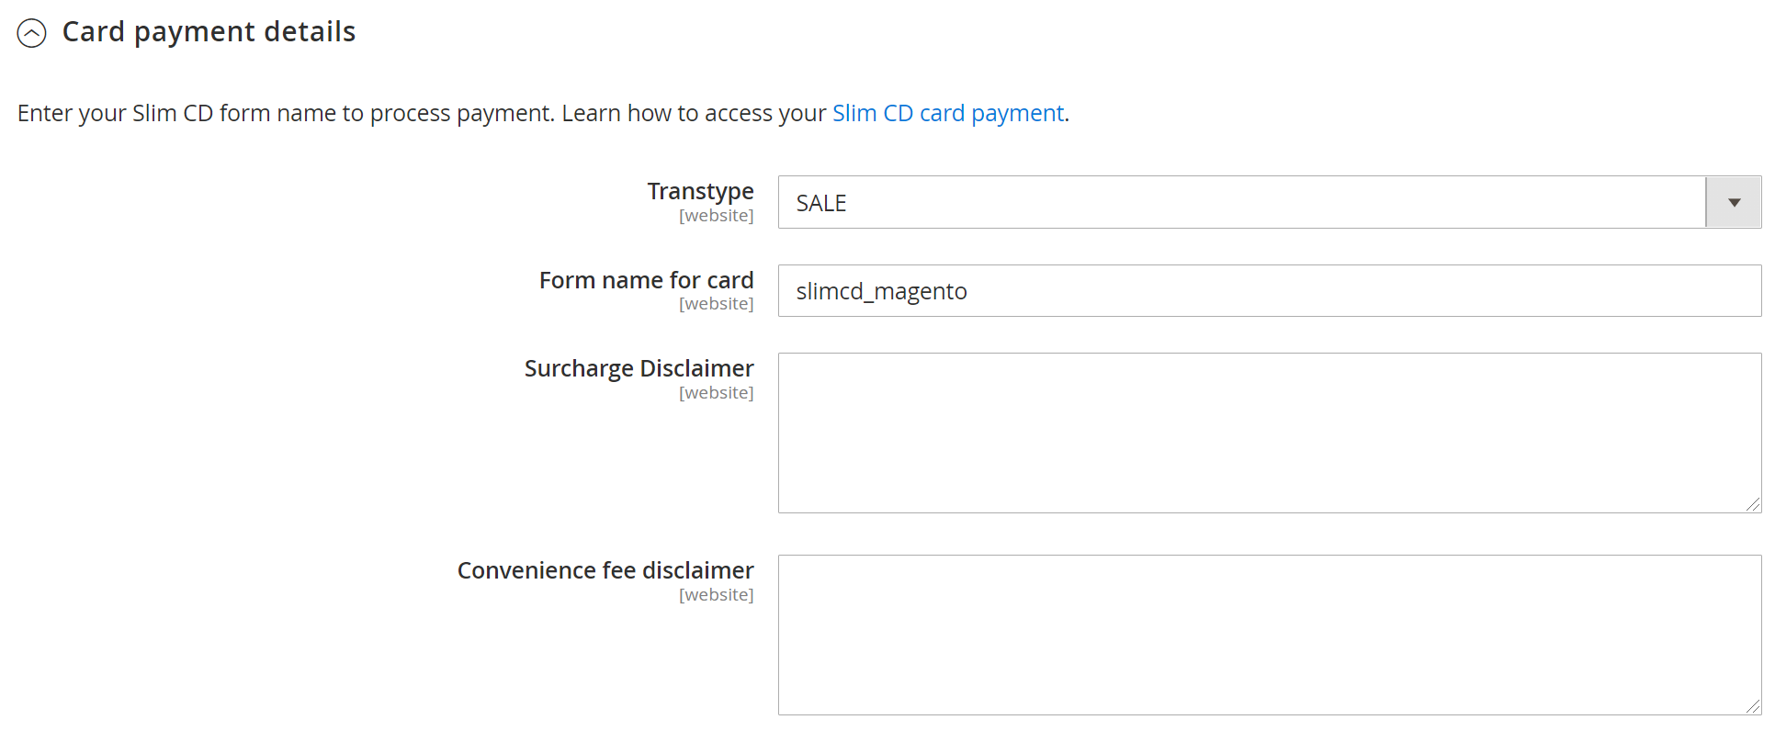
Transtype: choose which transaction type the cart should perform.
- Choose sale to have the page immediately charge the customer’s card.
- Choose AUTH if you wish the transaction to only be authorized (you will have to complete it with a FORCE within Slim CD to receive the funds).
Form name for card: the name of the hosted payment page used for credit card payment
Surcharge Disclaimer: if you have surcharge enabled on your account, enter the text you wish your customers to see regarding surcharge (will only appear if surcharge is enabled).
Convenience fee Disclaimer: if you have convenience fee enabled on your account, enter the text you wish your customers to see regarding convenience fee for cards (will only appear if convenience fee is enabled).
Check Payment Details
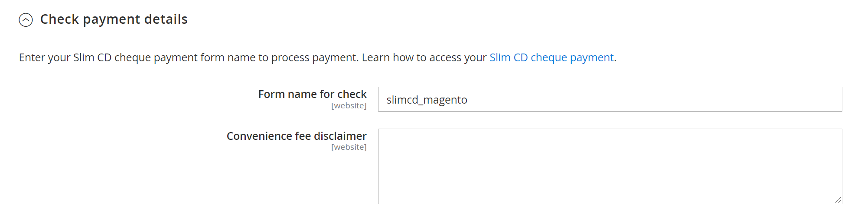
Form Name: the name of the hosted payment page on your account that is used for check payment
Convenience fee Disclaimer: if you have convenience fee enabled on your account, enter the text you wish your customers to see regarding convenience fee for checks (will only appear if convenience fee is enabled).

Results

From the shopping cart, a customer will be taken to the hosted payment page to complete their payment. The default cart will appear similar to the below screenshot, and the customer will be prompted to enter card number, expiration date, and amount (or routing and account number for ACH).
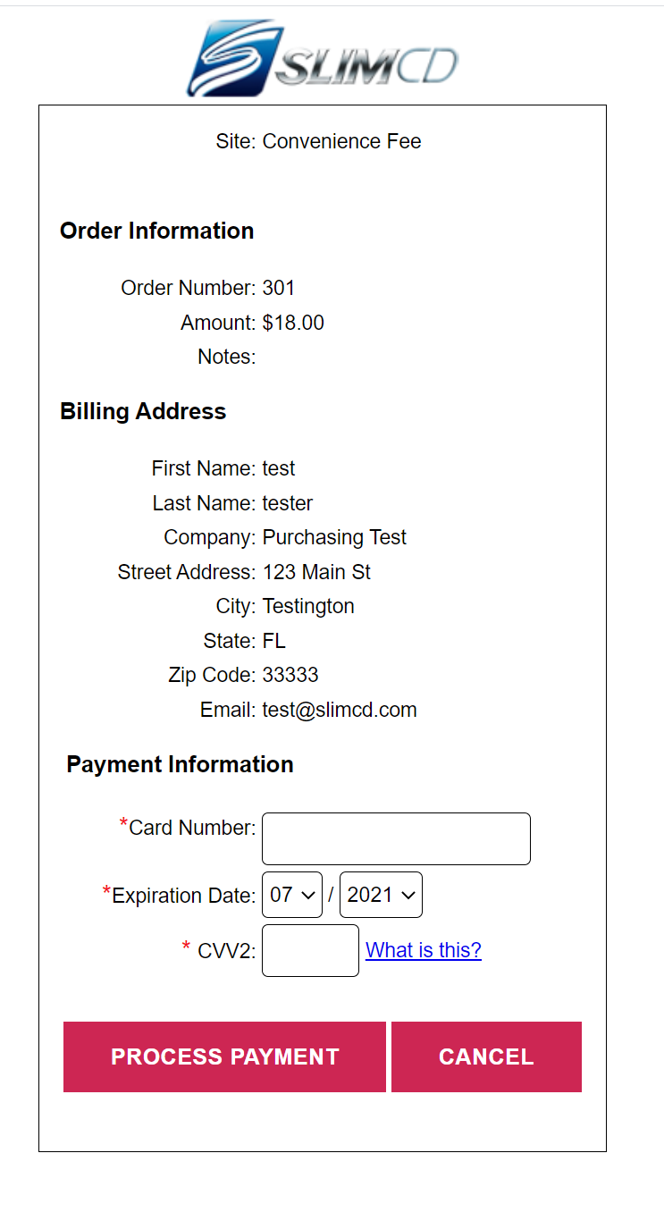
After payment, the customer will be redirected back to the shopping cart’s order confirmation page. The order number assigned by the cart will appear as the invoice number within the Slim CD gateway.

